TI 23 – 08 Technology Example – Resolute Expanding Polymer Grain

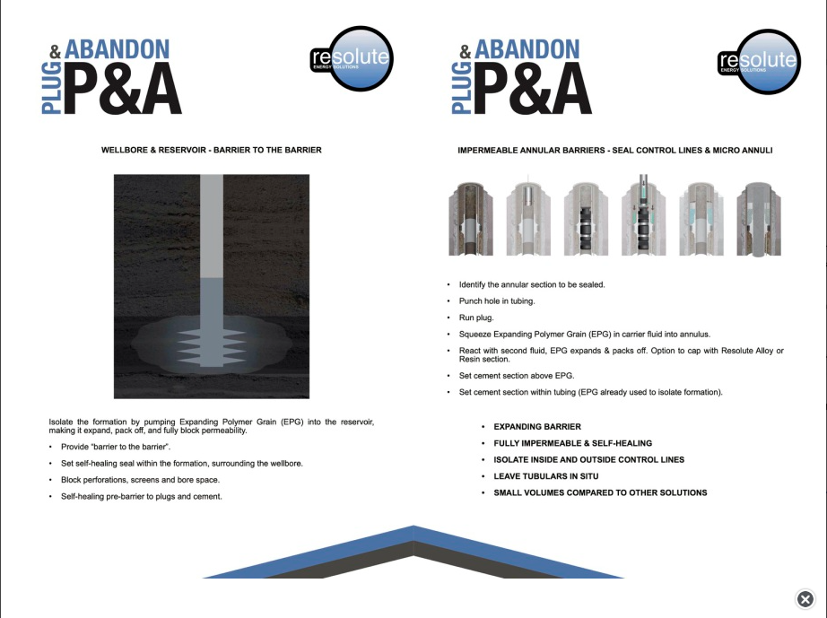

Vendors Webpage Link for further information on this technology:
Link: Resolute - Well P&A (resolute-energy.co.uk)

